User instruction for the service desk

To use the Home Assistant application at the Service Desk you need to follow these steps

1. 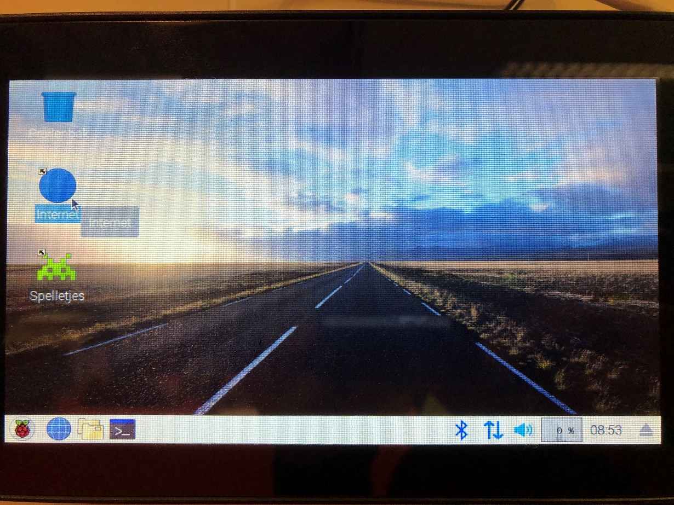You should see the desktop, from here you need to go to internet:
2. 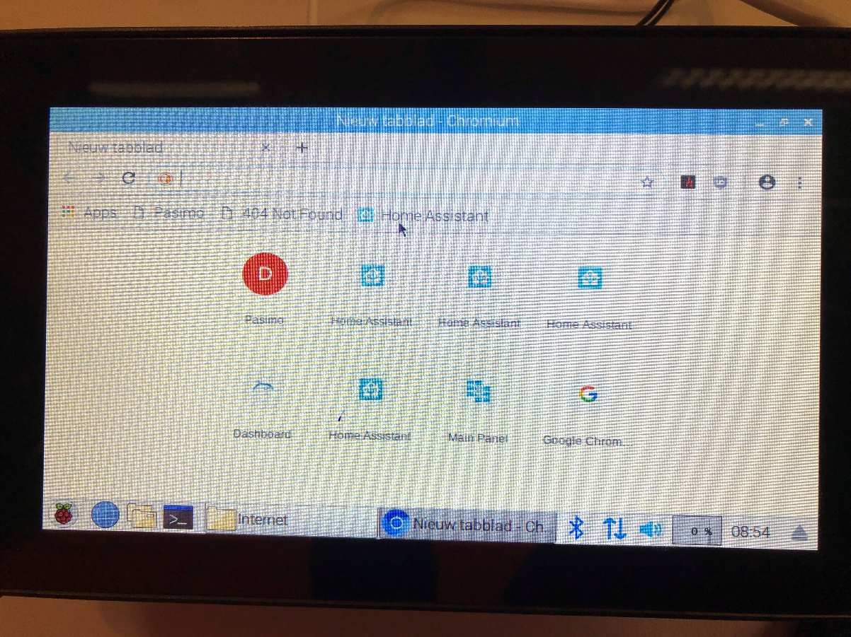When you are in the browser select the Home Assistant link under the URL bar:
3. 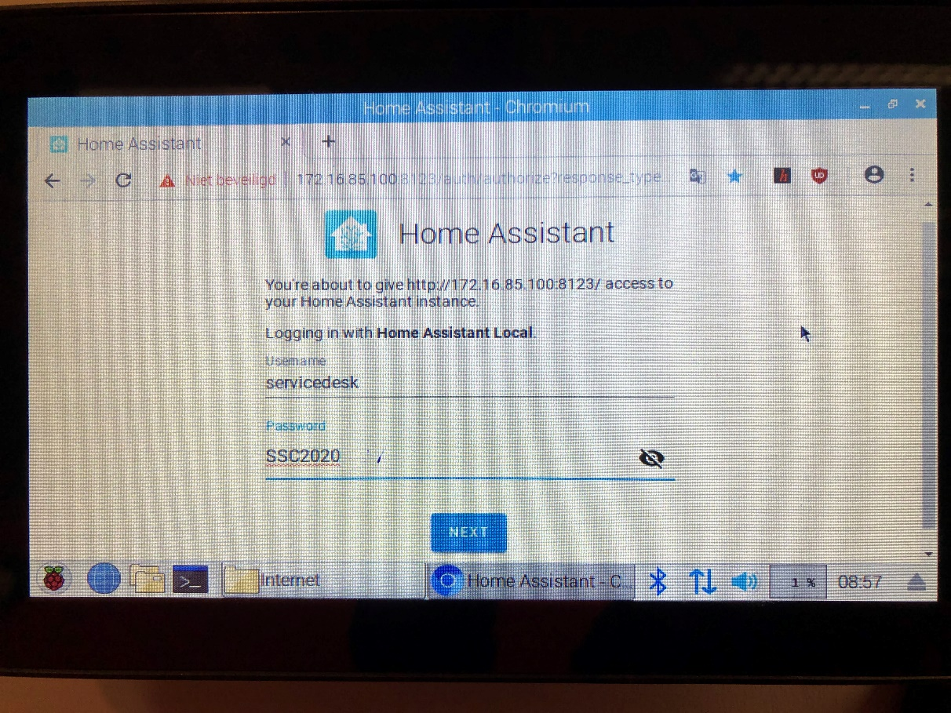You need to log in with the following username and password:
4. 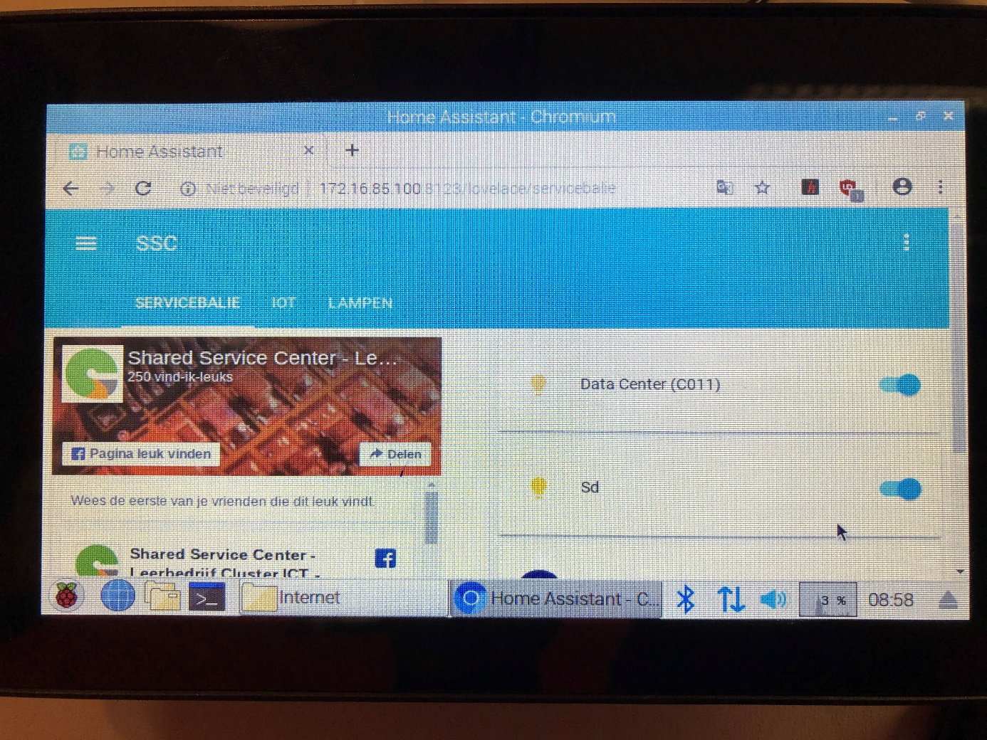If everything is done correctly you should see this screen: